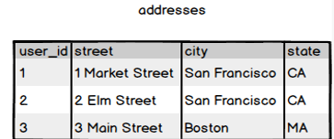
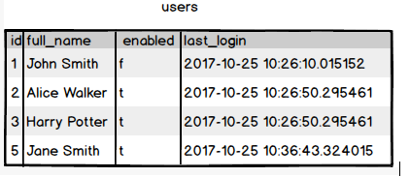
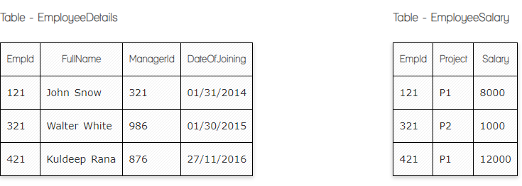
Hello Team! Consider the below two tables:

Ques.1. Write a SQL query to fetch the count of employees working in project 'P1'.
Your Answer:

SELECT COUNT(EmployeeSalary.EmpID)
FROM EmployeeSalary
WHERE EmployeeSalary.Project='P1'

Ques.2. Write a SQL query to fetch employee names having salary greater than or equal to 5000 and less than or equal 10000.
Your Answer:
SELECT EmployeeDetails.FullName
FROM EmployeeDetails
INNER JOIN EmployeeSalary
ON EmployeeDetails.EmpId=EmployeeSalary.EmpID
where EmployeeSalary.Salary between 5000 and 10000

Ques.3. Write a SQL query to fetch count of employees sorted by project's count in descending order.
Your Answer:
SELECT COUNT(EmployeeSalary.EmpID), project
FROM EmployeeSalary
group by project
order by COUNT(EmpID) desc

Ques.4. Write a query to fetch employee names and salary records. Return employee details even if the salary record is not present for the employee.
Your Answer:
SELECT EmployeeDetails.FullName, EmployeeSalary.Salary
FROM EmployeeDetails
LEFT JOIN EmployeeSalary
ON EmployeeDetails.EmpId=EmployeeSalary.EmpId
ORDER BY EmployeeDetails.FullName;

Ques.5. Write a SQL query to create an empty table with ‘Test’ name.
Your Answer:

create Table Test ( id int)

Ques.6. Write a SQL query to delete an empty table with ‘Test’ name.
Your Answer:

Drop table Test

Ques.7. Write a SQL query to fetch all the Employees details from EmployeeDetails table who joined in Year 2016.
Your Answer:
Select *
From EmployeeDetails
where DateOfJoining like '2016%'

Ques.8. Write a SQL query to insert new record to the EmployeeDetails table with any data.
Your Answer:
insert into EmployeeDetails(EmpId,FullName, ManagerID, DateOfJoining)
values ('37','Aram', '456', '2014/08/09');

Ques.9. Write a SQL query to update EmployeeSalery table with setting Salary to 2000 for Project P2.
Your Answer:
UPDATE Homework.EmployeeSalary
SET Salary = 2000
WHERE project = 'p2';

Ques.10. Write a SQL query to right join both tables and draw the results.
Your Answer:
select *
from EmployeeDetails
right join EmployeeSalary
on EmployeeDetails.Empid = EmployeeSalary.Empid;

Now take these two tables:

Ques.11. Write a SQL query to fetch all users full_name from San Francisco.
Your Answer:

Select Users.full_name
From Users
Inner join Adresses
on Adresses.user_id = Users.ID
where city = 'San Francisco'

Ques.12. Write a SQL query to fetch all users full_name, last_login who are enabled
Your Answer:
Select full_name, last_login
From Users
where enabled = 't'

Ques.13. Write a SQL query to fetch all users full_name who are not from Main street
Your Answer:
Select Users.full_name
From Users
Inner join Adresses
on Adresses.user_id = Users.ID
where not Street = 'main street'

Ques.14. Write a SQL query to fetch all users full_name who are from Main street or San Francisco
Your Answer:
Select Users.full_name
From Users
Inner join Adresses
on Adresses.user_id = Users.ID
where Street = 'main street' or city = 'San Francisco'

Ques.15. Write a SQL query to fetch user full_name who is equal to user_id from Boston (find user_id value in sub_query)
Your Answer:
select full_name
from Users
where ID = (
select user_id
from Adresses
where city = 'Boston'
);

